SECTION A: PERSON(S) INJURED / INVOLVED
PRIMARY PERSON INJURED / INVOLVED

Cyclist / Pedestrian / Motorist / Volunteer (circle)

First Name: |  | Last Name: |  | Contact #:
Address: |  | City/Prov: |  | Postal:
Male/Female/Unknown |  | Vehicle Make/Model: |  | Driver’s Licence (if motorist):
SECONDARY PERSON INJURED/INVOLVED/WITNESS

Cyclist / Pedestrian / Motorist / Volunteer / Witness (circle)

First Name: |  | Last Name: |  | Contact #:
Address: |  | City/Prov: |  | Postal:
Male/Female/Unknown |  | Vehicle Make/Model: |  | Driver’s Licence (if motorist):
ADDITIONAL PERSON INJURED/INVOLVED/WITNESS

Cyclist / Pedestrian / Motorist / Volunteer / Witness (circle)

First Name: |  | Last Name: |  | Contact #:
Address: |  | City/Prov: |  | Postal:
Male/Female/Unknown |  | Vehicle Make/Model: |  | Driver’s Licence (if motorist):
SECTION B: DESCRIPTION OF INCIDENT / ACCIDENT
Date & Time:

Cycle Stratford ride/event (e.g. destination ride, Sunday ride):

Type of incident/injury (circle)
Medical Aid/Paramedic | First Aid Only |  | Near Miss/Incident Only |  | Property Damage
Location (intersection, trail name, closest landmark):

Who was involved (cyclist, pedestrian, vehicle):

What happened (include cause of incident, what was cyclist doing when incident occurred):

Environmental conditions (cycling surface, weather, lighting):

Was there an injury? Yes / No

Was medical attention offered? Yes / No

Was medical attention received on site? Yes / No

Details of injury (if applicable): |  | Body Parts  Head  Face  Neck/Spine  Shoulder R/L  Back  Chest  Arm – Upper R/L  Elbow R/L  Arm – Lower R/L  Hand R/L  Abdomen  Groin  Leg – Upper R/L  Knee R/L  Calf R/L  Heel R/L  Ankle/Foot R/L |  | Body Parts Injured (circle):  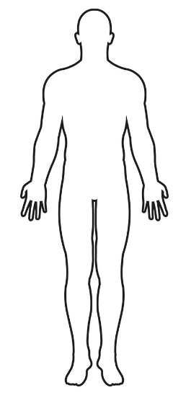
Record time and action of medics/ambulance:

Where was the injured party transported to?

Record times and action of police, if attended location (include officer names/badge numbers):

Details of property damage (bike, property):

Any other information relevant to the incident/injury:

SECTION C: PERSON COMPLETING REPORT
First Name: | Last Name: |  | Contact #:
Email Address:

Relationship to Cycle Stratford:

SECTION D: SAFETY COMMITTEE USE ONLY
Notes on follow up action (who, what, dates, action, etc.):

Email the completed form to the Cycle Stratford Safety Officer programscyclestratford@gmail.com

